**seNSCI 20100 Neuroscience Laboratory**

**Electro-oculogram Recordings**

**BSLC 322, January 10 & 12, 2018**

**Goals:** In this lab, you will record electro-oculogram (EOG) signals related to saccadic eye movements of different amplitudes. With these data, you will examine the relationships between saccade amplitude, duration and speed. You will gain experience with filtering and averaging microvolt analog signals to obtain high quality measurements, and intuition for the power and limitations of signal processing.

**Reading:** Before the lab, you should read overview material by Carpenter (1988) and Collewijn (1999), which you will find on the Canvas site. If you are interested in reading research results from one of the earliest applications, you might look at the following article, which is also on the site:

Fenn, W.O. and Hursh, J.B. (1934) Movements of the eyes when the lids are closed. *American Journal of Physiology*, 118:8-14.

**Safety:** Once the EOG electrodes are installed, keep the leads protected and away from water and electrical sources until they are inserted into the isolation unit. No personal protective equipment (PPE) is required or recommended.

**Data:** You will collect eye position traces for saccades of four different sizes. You should collect data from both students in each pair (complete data collection from the first before beginning the second).

**Clean up:** When you have finished, you should quit Matlab, collect any data files from the lab machine and discard your files on the lab machine. You do not need to log out, reboot or shutdown the computer.

Clean the EOG electrodes as described in the procedures.

**Lab Report:** Lab reports should be prepared following the general instructions found on the course [Canvas site](https://canvas.uchicago.edu/courses/11181/assignments/syllabus). In preparing your report, you should consider the following:

*Introduction:* What are saccadic eye movements? What is the biological basis of the EOG?

*Methods:* Describe the procedures that were used. If your average velocity traces show movements before the onset of the saccade, explain why.

*Results:* Include a figure showing your data in your report. How are your saccades of different sizes related (same duration? same constant acceleration? same constant acceleration to a limiting speed?). Are the results consistent between subjects? Does reaction time differ between stimulus step sizes? What are the fastest reactions time? Some of the application warnings you have been told to ignore arise because the timing of the visual stimulus steps is not entirely reliable. How will jitter in the actual time of the step affect your results? The LabJack collects voltages samples at precise intervals, but the computer might not collect them for 10-20 ms. Will this affect your data?

*Discussion:* Given that load on the eye muscles is constant (one eyeball), what can you infer about the forces generated by the eye muscles during saccades of different sizes. What might affect whether reaction time differs for different stimulus step sizes?

**Laboratory Procedures**

***Hardware:***

*Recording Equipment:* Some or all of the hardware and cabling will need to be set up. The small switch at the other end of the C-ISO-256 should be set to 2.5 kHz. The cable from the C-ISO-256 should be connected to left input of the iWorx ETH-256 amplifier. The initial settings for Channel 1 on the iWorx amplifier should be: “DC” HPF (high-pass filter); “50 Hz” LPF (low-pass filter); and “x10” gain. The settings are indicated by small red LEDs, and are changed by pressing the appropriate black button. You may change these setting to improve the quality of your data. The settings for Channel 2 are irrelevant.

Use a BNC T-adaptor to connect two BNC cables from Output 1 of the ETH-256. One cable should be connected to a LabJack U6 computer data acquisition unit. To do this, a BNC-20G wire adaptor will need to be installed to the LabJack’s AIN0 (red wire) and GND (black wire) inputs. The LabJack U6 should be connected to the iMac computer with a USB cable.

The other BNC cable should be connected to voltage (or vertical) channel 1 of an oscilloscope. The oscilloscope should initially be set to ~500 mV/division (vertical) and ~5 ms/division (horizontal). Make sure the voltage channel is set to “AC” (not “DC” or “ground”/”GND”). Set the oscilloscope to trigger to “line” (not “Channel 1”, “Channel 2”, or “External), and the trigger mode to “Normal” (not “Auto”)**.**

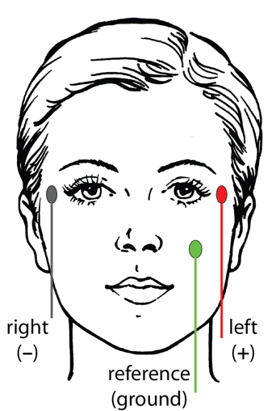*EOG Electrodes*: You will record the EOG using three electrodes. Two active electrodes are positioned immediately lateral to the eyes. The remaining reference electrode should be placed on the left check immediately below the eye.

Use an electrode prep pad to gently clean the skin at three sites. Avoid getting alcohol from the pad in your eyes. Allow the skin to dry completely before attaching the electrodes.

To attach each electrode, remove the protective paper from one side of a sticky pad and attach the pad to the electrode face. Remove the outer protective paper from the sticky pad and place the pad and electrode on the skin with the wire oriented downward. Once gentle pressure has been applied, the electrode should remain attached. Drape the wire over your shoulder or put it in a shirt pocket to keep it from getting pulled. Apply a small amount of electrolyte gel to the electrode using the syringe and blunt needle. Pass the blunt needle through the hole in the electrode and gentle push the plunger until gel comes out the hole. Attach the remaining two electrodes.

Plug the electrodes into the C-ISO-256 isolation unit. The jacks are color coded according to the diagram above. It does not matter if the electrodes you have are different colors, but you should insert them according to the color coding above (red-left, black-right).

***Software:***

You will use a Matlab application to collect your data. The necessary software is installed and configured on each of the lab’s computers. Use the following procedures to run the software.

1) Log into the “labuser” account. There is no password for this account: Do not enter anything in the password field.

2) Launch Matlab by clicking on the Matlab icon in the dock at the bottom of the display. (Matlab might have a date appended to its name, such as “Matlab_2017a”.)

3) When it launches, Matlab will display a large, multi-paneled window. Launch the EOG application by entering “EOG” in the Matlab “Command Window” at the bottom of the Matlab window.

4) The EOG application will take several seconds to launch, and it will display warnings in the Matlab “Command Window” and the display window that is created on the screen. You can safely ignore all these warnings. Once the EOG application has finished launched, you will see two new windows, which are described below.

5) When you have finished collecting and saving your data, you can terminate the EOG application by either 1) closing the EOG control panel window using its close button (red button in the upper left corner), 2) closing the Matlab window using its close button, or 3) making Matlab quit using Quit in the File Menu (or the keyboard equivalent, command-Q). In any case, you will be asked whether you are sure you want to quit. All unsaved data will be lost when you quit.

../../Screen%20Shot%202017-12-11%20at%2018.30.33.png

**Signal Assessment:** Before running the computer program, you should use the oscilloscope signal to assess the quality of your recordings. Turn the **Offset** knob on the ETH-256 amplifier to bring the trace to ~0V on the oscilloscope display. You should see little 60 Hz noise (16.7 ms cycle) and clear upward and downward deflections of the voltage trace when gaze is shifted leftward and rightward. You should also explore the consequences of clenching your teeth while recording EOGs. Ask an instructor to evaluate your signal before collecting data.

**Running the EOG Task**

The stimulus display will appear as a long, thin dark gray window at the bottom of the monitor. The control/display panel will appear above and to the right. You should familiarize yourself with the controls and displays and run test trials before you start collecting data you plan to use. You can clear any test data before you start any serious data collection.

The task involves following the small white dot with your eyes. At regular intervals, the white dot will jump left or right at random by 5°, 10°, 15° or 20°. You should simply do your best to keep your gaze on the dot. It is not important that you have a fast reaction time, but you should shift your gaze to follow the dot shortly after it moves. It is important that you do not look away from the dot while you are collecting data. For this reason you will want to pause and restart your data collection frequently.

**Saccade Detection:** The application detects saccades using the following approach. A saccade is detected when the position trace first crosses the **Saccade Threshold** after the stimulus onset (the dash-dotted line). (If not enough trials have been run for the application to establish a calibration, it will assume that the maximum voltage in the trace corresponds to the stimulus step size on that trial.) The application will search back in time to the point where the filtered velocity became positive (relative to the direction of the saccade), and count that as the start of the saccade. It will then search forward in time to the first position maximum, and count that as the end of the saccade. You may need to adjust the saccade threshold once the application is calibrated with a few dozen trials.

**Settings:** Before collecting data, you must adjust the task settings. You must enter the **Viewing Distance**. To set the viewing distance, find a comfortable viewing position and measure the approximate distance from your eyes to the screen. This should generally be 50 to 75 cm. You must enter this value before data collection to ensure that the stimulus steps are calibrated.

You should adjust the **Filter Width** so that you can reliably see the small (5°) saccades. The eye velocity data are smoothed with a boxcar filter, the width of which is set by this entry. Eye positions are sampled every 1 ms, so a value of 1 ms corresponds to no filtering. Too little filtering will leave you with noisy data that will require you to collect many samples. Too much filtering will remove high frequencies and distort the dynamics of the eye movements. You should not change this setting after you start collecting your date.

Once the filter width is set, you should adjust the **Saccade Threshold** so that you reliably detect most of the small saccades without allowing fluctuations in the noise to be classified as saccades. It is better to miss some saccades than to include spurious signal fluctuations as saccade. The program detects the start and end of each saccade using a speed threshold. The threshold is visible as horizontal lines in the most recent velocity trace (plot 3). The threshold is applied to the filtered traces. Five consecutive values above the threshold are counted as the start of a saccade. After a saccade starts, the first five consecutive values below the threshold are counted as the end of the saccade.

**Breaks**: You should take frequent breaks, but you should not leave the task running when you pause. You should be tracking the spot with your eyes whenever the task is running. You can use the **Start/Stop** button to toggle the task run state. For convenience, you can also use the space bar to toggle the run state if the control panel is front-most. This allows you to pause the task without looking at the control panel.

**Controlling the EOG Task**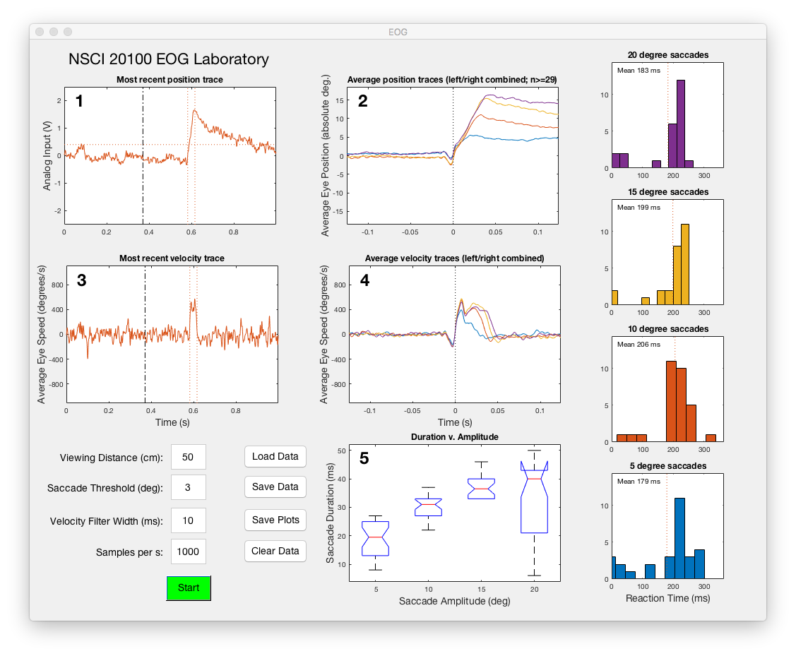

The following controls are found at the bottom left of the Control Panel.

**Start (Stop):** Toggle whether the task is running. You can also use the space bar when the control window is front-most.

**Viewing Distance (cm):** The distance from your eyes to the screen. This value must be set before data collection to ensure that your position and speed measures are properly calibrated.

**Filter Width (ms):** The width of the boxcar filter that smooths the eye position traces (and thereby the eye velocity traces).

**Saccade Threshold (deg/s):** The program detects the start and end of each saccade using a speed threshold. You can adjust that threshold here. The threshold is applied to the filtered traces. If your filtered trace is noisy, you will need to set the threshold higher to avoid spurious detections. If your filtered traces are less noisy, you can set the threshold lower to get more precise measurements of the saccade dynamics.

The following displays are plotted in the control/display panel:

**1) Most recent position trace:** The most recent position trace is displayed. The difference between the two EOG electrodes is plotted as a function of time. Rightward and leftward eye movements correspond to up (positive) and down (negative) on this and other displays. A dotted-dashed line marks the stimulus movement. If a saccade is detected, its duration (above saccade speed threshold) will be marked by vertical lines. Each trace is offset vertically so that the pre-movement portion of the trace lies at y = 0 V. In this and all other panels, colors correspond to the size of the target step.

**2) Average position traces:** A separate average is computed for each of the four target step sizes, but leftward and rightward steps of the same size are combined by flipping one direction before averaging. Before averaging, individual traces are offset so that the pre-saccadic period lies at y = 0 V, and the start of the saccade is aligned at t = 0 s. The y axis is scaled in degrees by assuming that the average post-saccadic position is offset from 0 by the size of the target step. If no saccade is detected on a given trial, that trace will not be included in the average.

**3) Most recent velocity trace:** The most recent velocity trace is displayed. This curve is the derivative of the most recent position trace plotted in panel 1, boxcar-filtered with a width specified by the **Filter Width (ms).** Calibration is in V/s until enough traces have been collected to establish a voltage-to-position calibration, after which it is plotted in units of deg/s. Horizontal lines mark the saccade threshold for leftward and rightward saccades. Vertical lines mark the stimulus step and the duration of any detected saccade.

**4) Average velocity traces:** A separate average is computed for each of the four target step sizes, but leftward and rightward steps of the same size are combined by flipping one direction before averaging. These curves are based on the derivatives of the traces that were used to compute the average position traces in panel 2. Colored lines below the traces mark the period where the average velocity is above the saccade threshold.

**5) Saccade duration versus amplitude:** Saccade duration in milliseconds is plotted as a function of the four saccade amplitudes in a box format (whiskers have been omitted from this box-and-whisker plot).

The column of plots at the right edge of the display panel plots saccadic reaction times for the different step sizes. There is one entry for every trial on which a saccade was detected. The value is the delay between the step occurrence and the onset of the saccade.

**Clean up:** Immediately after removing the EOG electrodes, wash out the gel or cream using distilled or deionized water. Do not use tap water. A cotton swab can be used to remove the main bulk of the gel or cream. Do not scratch the metal surface of the electrode. You can remove any gel from your face with a wet paper towel.